

Human Biology ATAR – Task 5: Test
Digestive, Excretory and Musculoskeletal Systems (6%)
Name:
Time allowed: 55 Minutes + 5 minutes reading time
Section | Your Mark | Marks available | Percentage of Test
Multiple Choice (A) |  | 15 | 25%
Short Answer (B) |  | 35 | 58%
Extended Response (C) |  | 10 | 17%
 |  | 60 | 100%

Declaration of Authenticity
I (Student Name) _____________________ declare that this work is my own and I have not plagiarised from any source.

Signature:
Date:

Section A – Multiple Choice (15 marks)
Answer all questions by clearly circling the letter ONLY. Use only a BLUE or BLACK pen. If you make a mistake, place a CROSS through the letter; do not erase or use correction fluid, and circle your new answer. Marks will not be deducted for incorrect answers. No marks will be given if more than one answer is completed for any question
- The series of muscular contractions that moves food along the digestive tract is called:

  - Periosteum
  - Peristalsis
  - Pericardium
  - Perimysium

- Urine is stored in the:

  - Kidney
  - Bladder
  - Urethra
  - Ureter

- The flap of tissue that covers the trachea during swallowing is called the:

  - Glottis
  - Epiglottis
  - Peristalsis
  - Larynx

- The process of deamination occurs in the:

- Kidney
- Pancreas
- Stomach
- Liver

- The projections found along the walls of the small intestine are called:

- Mucosa
- Villi
- Rennin
- Ileum

- Which of the following reactions is catalyzed by lipase?

  - Starch to maltose
  - Fats to fatty acids
  - Polypeptides to amino acids
  - Fatty acids to micelles

- Absorption of digested food occurs largely in the:
- Small intestine
- Pancreas
- Stomach
- Large intestine

- Bile is involved in the breakdown of fats. It is:

- Produced in the gall bladder and stored in the liver
- Produced in the liver and stored in the gall bladder
- Produced in the pancreas and stored in the liver
- Produced and stored in the liver

- In the sliding filament theory of muscle contraction which of the following occurs:

  - The I bands lengthen
  - The actin filaments slide past the myosin filaments
  - The Z lines move further apart
  - The A band shortens

- The vertebral column, rib cage and skull form the:

  - Axial skeleton
  - Appendicular skeleton
  - Pectoral girdle
  - Pelvic girdle

- The shaft of a long bone is called the:

  - Periosteum
  - Trabuculae
  - Diaphysis
  - Epiphysis

- Blood in the glomerulus is under high pressure due to

- The pressure applied by the renal artery and the small diameter of the efferent arteriole
- the pressure applied by the renal artery and the small diameter of the afferent arteriole
- The pressure applied by the renal vein and the small diameter of the efferent arteriole
- The pressure applied by the renal vein and the small diameter of the afferent arteriole

13. Where would you not expect mechanical digestion to take place?

  - Stomach
  - Mouth
  - Small intestine
  - Large intestine

  - In order to bend the arm at the elbow the biceps muscle must contract. At the same time the triceps muscle must?

- Relax
- Shorten
- Push on the ulna
- Pull on the radius

  - Which line represents the process of deamination?

    - Amino acid + carbohydrate ammonia + oxygen
    - Ammonia + carbohydrate amino acid + oxygen
    - Amino acid + oxygen carbohydrate + ammonia
    - Ammonia + oxygen amino acid + carbohydrate

Section B – Short Answer
Answer all questions in the spaces provided. Use only BLUE or BLACK pen.

- Name a part of the alimentary canal that is involved in (4 marks)

- Secretion of enzymes
MOUTH / SALIVA, STOMACH, SMALL INTESTINE (PITS), PANCREAS
- Absorption of nutrients
SMALL INTESTINE, LARGE INTESTINE (VITAMINS/NUTRIENTS)
- Peristalsis
OESOPHAGUS, LARGE INTESTINE, SMALL INTESTINE
- Defecation
RECTUM (STORED), PUSHED THROUGH ANUS
- The diagram below shows a single villus

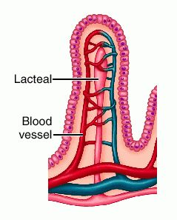
(iii)

(i)

(ii)

- Label the following parts (3 marks)

(i) LACTEAL
(ii) CAPILLARY
(iii) MICROVILLI/Epithelium

- Where are villi found in the digestive system? (1 mark)

SMALL INTESTINE – WALLS OF – ALL ALONG THE LENGTH

- Why are the villi so small and so numerous? (1 mark)

TO INCREASE SURFACE AREA FOR ABSORPTION TO OCCUR

- Use the diagram of a kidney to fill in the missing labels (5 marks)

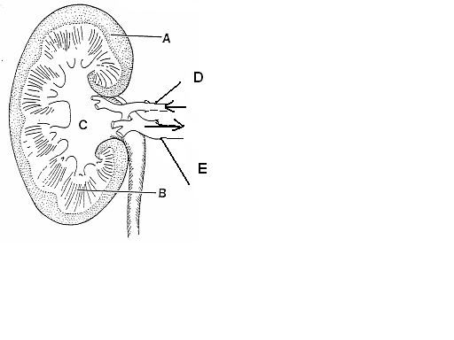

A CORTEX
B MEDULLA/RENAL PRYAMID
C PELVIS
D RENAL ARTERY
E RENAL VEIN

- What is the name of the structure that INITIALLY filters the blood in the kidney? (1 mark)

BOWMAN’S CAPSULE / GLOMERULAR CAPSULE
- The tube leading from the bladder to the outside is called? (1 mark)

URETHRA

- What happens to the urine output if the body fluids contain less water? (1 mark)

DECREASES

- Label the attachments marked A to F on the diagram below (6 marks)

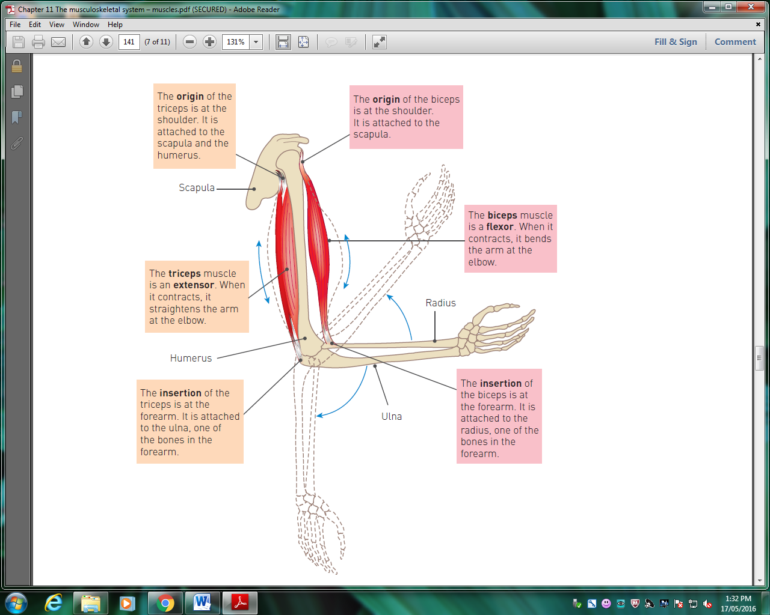
C- origin biceps
D- origin triceps

B- biceps muscle

E- triceps muscle

A-Insertion biceps
F- insertion triceps

- B and E are antagonistic muscles. Explain how these two muscles work together to cause
(4 marks)
(i) Flexion
B-BICEPS - contracts - bends the arm
(ii) Extension
E – TRICEPS – Contracts – extending the arm

- The Digestive System extracts nutrients from the food we eat and absorbs them into the body for use by cells.

              - Complete the below table by identifying the simpler units that these nutrients are broken down into during digestion. (3 marks)

Large, complex molecule | Small, simple molecule
Proteins | Amino Acid (also accept peptide)
Carbohydrates | monosaccharide
Fats | Fatty Acid or glycerol

              - A Cholecystectomy is a surgical procedure where the gallbladder is removed, most often used to treat painful gallstones. People who have had their gallbladder removed are unable to control the release of bile into the small intestine. Predict a possible consequence of this. (1 mark)

They will have difficulty digesting fats

              - Complete the table to compare and contrast mechanical digestion with Chemical Digestion. (4 marks)

Similarities
Similarities: Both take something larger and make it smaller.
Mechanical and chemical digestion occurs in the mouth, stomach and small intestine.

Differences
Mechanical digestion | Chemical digestion
- Mechanical digestion is a physical process, so no new substances are formed.  - mechanical digestion does not.  Other acceptable | - Chemical digestion produces new products from larger, more complex molecules.  - Chemical digestion requires enzymes

Section C – Extended Response
Write your answer on the lined pages provided. Answers should be in BLUE or BLACK pen
- The formation of urine by the nephron of the kidneys involves three major processes; filtration, reabsorption and secretion in the tubules. Explain each of these processes in detail (10 marks)

Filtration:
- Occurs at the renal corpuscle
- Blood is transported in through the afferent arteriole
- The efferent arteriole has a smaller diameter which leads to pressure build up in the glomerulus
- This high pressure pushes out most of the substances from the blood into the tubule/glomerular capsule
- This fluid is referred to as filtrate
- It contains everything except red and white blood cells and large proteins which cannot transfer out of the arteriole OR it contains (states at least 4) water, salts, amino acids, fatty acids, glucose, urea, uric acid, creatinine, hormones, toxins and various ions.

Reabsorption:
- Selective reabsorption involves reabsorbing substances from the filtrate back into the blood vessels that are useful for the body
- Reabsorb (lists at least 3) water, glucose, amino acids and ions (e.g. sodium potassium), bicarbonate
- Water reabsorption occurs through simple diffusion in the proximal convoluted tubule, and descending loop of Henle.
- Water reabsorption also occurs through facultative reabsorption which is controlled hormonally at the distal convoluted tubule and collecting duct.

Secretion:
- Involves adding substances from the blood into the tubule.
- Substances secreted into the tubule are (lists at least 3) potassium, hydrogen, ammonium, urea, uric acid, creatinine and some drugs

